How to create database link to different oracle server using sql developer
Create new user & grant
grant connect,resource to MONITORING
grant create database link to MONITORING

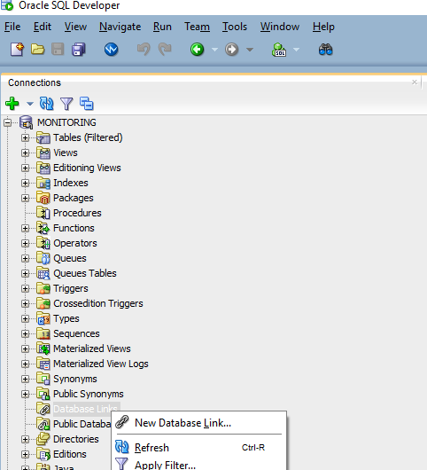

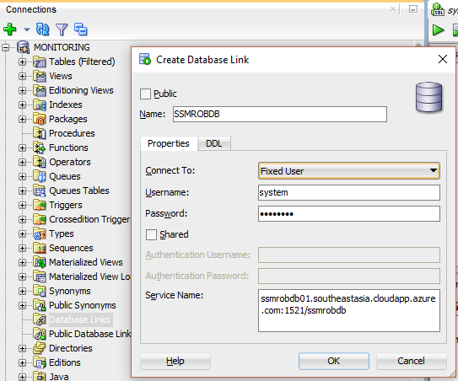
ssmrobdb01.southeastasia.cloudapp.azure.com:1521/ssmrobdb
CREATE DATABASE LINK SSMROBDB
CONNECT TO system IDENTIFIED BY Passw0rd
USING 'ssmrobdb01.southeastasia.cloudapp.azure.com:1521/ssmrobdb';

select * from rob_lov_business_codes@SSMROBDB

